Innomaker Echo and buffer FAQ

# Introduce

There is an send buffer context management,When you open device you must reset the send buffer context,when you send buffer you must request an empty context ,when you receive buffer (echoed != 0xffffffff means echo frame) you must release the context.

If any question,You can read the source code in the examples.

## You must reset tx buffer when open device

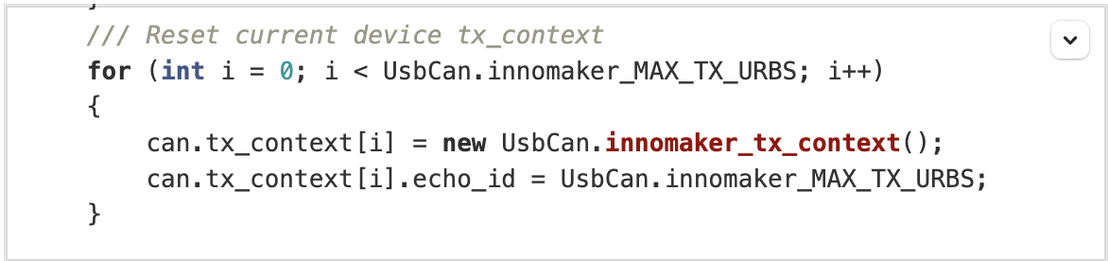

## You must alloc an empty context when send buffer

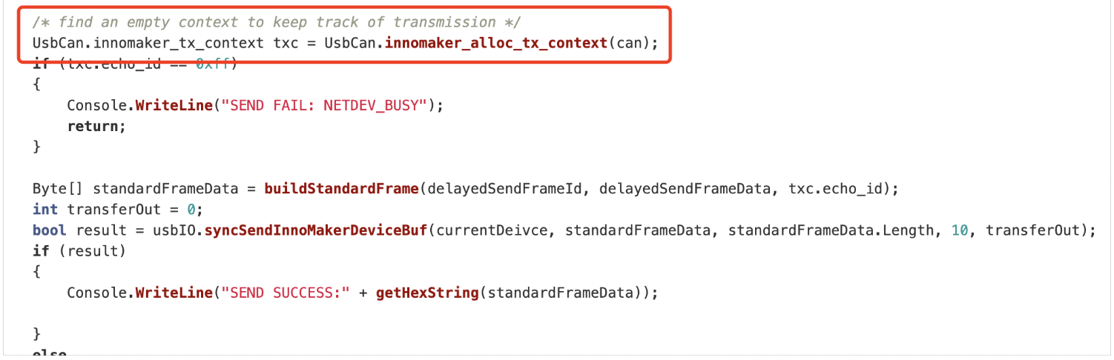

## You must dealloc an context when you receive an echo frame

